CREATE DATABASE EmployeeDB ;
CREATE TABLE EMPLOYEE (
SSN int IDENTITY (1,1) PRIMARY KEY,
FNAME VARCHAR(50) Not null,
MINIT int,
LNAME VARCHAR(50) Not null,
BDATE DATE,
empADDRESS VARCHAR(50) Not null,
SALARY DECIMAL(10,2),
gender varchar (20) Not null ,
DNO int ,
SUPERSSN int ,
FOREIGN KEY (SUPERSSN) REFERENCES EMPLOYEE(SSN),
FOREIGN KEY (DNO) REFERENCES DEPARTMENT(DNUMBER)
);
\\\\\\\\\\\\\\\\\\\\\\\\\\\\\\\\\\\\\\\\\\\\\\\\\\\\\
CREATE TABLE DEPARTMENT (
DNUMBER INT PRIMARY KEY,
DNAME VARCHAR(20) UNIQUE,
MGRSSN int(9),
MGRSTARTDATE DATE,
FOREIGN KEY (MGRSSN) REFERENCES EMPLOYEE(SSN)
);
/////////////////////////////////////////////////////////
CREATE TABLE DEPT_LOCATIONS (
DNUMBER INT,
DLOCATION VARCHAR(20),
PRIMARY KEY (DNUMBER, DLOCATION),
FOREIGN KEY (DNUMBER) REFERENCES DEPARTMENT(DNUMBER) );
\\\\\\\\\\\\\\\\\\\\\\\\\\\\\\\\\\\\\\\\\\\\\\\\\\\\\\\\\\\\\\\
CREATE TABLE PROJECT (
PNUMBER INT PRIMARY KEY,
PNAME VARCHAR(20) UNIQUE,
PLOCATION VARCHAR(20),
DNUM INT,
FOREIGN KEY (DNUM) REFERENCES DEPARTMENT(DNUMBER)
);
\\\\\\\\\\\\\\\\\\\\\\\\\\\\\\\\\\\\\\\\\\\\\\\\\\\\\\\\\\\
CREATE TABLE WORKS_ON (
ESSN int(9),
PNO INT,
HOURS DECIMAL(4,1),
PRIMARY KEY (ESSN, PNO),

);
//////////////////////////////////////////////////////////////
CREATE TABLE DEPENDENT (
ESSN CHAR(9),
DEPENDENT_NAME VARCHAR(15),
SEX int(1),
BDATE DATE,
RELATIONSHIP VARCHAR(15),
PRIMARY KEY (ESSN, DEPENDENT_NAME),
FOREIGN KEY (ESSN) REFERENCES EMPLOYEE(SSN)
);

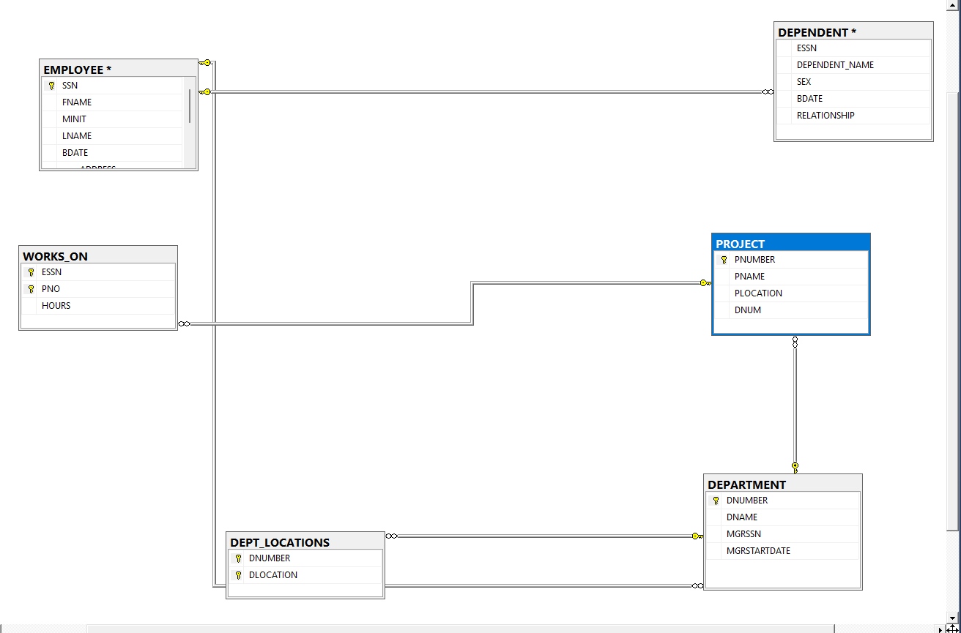
INSERT INTO EMPLOYEE VALUES
('111111111','Ali','A','Hassan','1990-01-01','Cairo','M',5000,NULL,1),
('222222222','Sara','M','Ahmed','1992-02-02','Giza','F',4500,'111111111',1);
INSERT INTO DEPARTMENT VALUES
(1,'IT','111111111','2020-01-01');
INSERT INTO DEPT_LOCATIONS VALUES
(1,'Cairo'),
(1,'Giza');

INSERT INTO PROJECT VALUES
(10,'Website','Cairo',1);
INSERT INTO WORKS_ON VALUES
('111111111',10,20),
('222222222',10,15);
INSERT INTO DEPENDENT VALUES
('111111111','Omar','M','2015-05-05','Son');

Relationship | Type
Department – Employee | 1 : N | القسم الواحد فيه موظفين كتير
Employee – Employee (Supervisor) | 1 : N | موظف واحد يشرف على عدة موظفين
Department – Project | 1 : N | القسم الواحد يدير أكثر من مشروع
Employee – Project | M : N | الموظف يعمل في أكثر من مشروع
Employee – Dependent | 1 : N | الموظف له أكثر من تابع

Normalization Rules

First Normal Form (1NF)
- مفيش multi-valued attributes
- كل الحقول atomic ✔

Second Normal Form (2NF)
- الجداول اللي ليها Composite Key (WORKS_ON, DEPENDENT)
- كل الأعمدة تعتمد على المفتاح بالكامل ✔

Third Normal Form (3NF)
- مفيش Transitive Dependency
- كل Attribute يعتمد فقط على Primary Key ✔

